AMANA TRUST DIAGNOSTICS
No 15, Tudun Wada C, Nasarawa LGA, Kano State.
Phone; +2348164093504, +2348033390574
Email; amanatrust2022@gmail.com

11/3/2025 4:16 PM
NAME: SHUKURA SURAJUDDEEN | Age: 25y | Sex: F | Ref No:00010
Clinical Details: USG Pelvic |  |  |  | US:10

REAL TIME PELVIC ULTRASONOGRAPHY EXAM: REVEALED:

URINARY BLADDER: Distended with urine with normal mucosal thickness. No gross masses or stone seen.

UTERUS: Anteverted and empty. Normal in size and contour. Myometrial and central endometrial echoes are preserved. However, a roundish hypoechoic lesion in myometrium is seen causing ill-definition of endometrial plate, measuring 18 mm X 19 mm.

ADNEXAE: Right Shows cystic lesion with no internal nodules, septae or debris with good posterior acoustic enhancement. It measures about 19 mm X 20 mm. Left adnexia appeared preserved.

CUL-DE-SAC: No sonographic abnormalities detected in anterior and posterior cul-de-sac.

CONCLUSION: The USS Features are suggestive of Uterine Fibroid with co-existing Right Simple Ovarian Cyst.

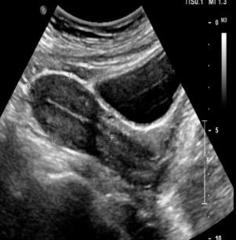

Ultrasound specialist.

